**Question Creator Form Documentation**

This document is a documentation of the Question Creator windows form application, it will be sectioned off into three sections, **End user documentation**, **Developer documentation**.

**End user documentation**:

The Questions application is an application that helps manage lists of questions by editing, adding and deleting them, so they can be used in an actual survey or to be used in other applications.

This documentation will walk you through how to do each and every single of the above abilities

**Changing the language:**

Firstly we will go through how to change the language, and the user is provided with two options, Arabic and English.

**Step 1:**

Load up the application.

**Step 2:**

Press the settings button.

**Step 3:**

A new window will pop and there will be a drop down list that contains Arabic and English, the currently selected language will show in the box.

**Step 4:**

Chose the wanted language from the drop down then a pop-up message will show letting you know that the language was changed and a restart Is needed, then the application will restart and the selected language will be the main language.

**Note:** There will be other options to change in the settings window but please be careful on what you change if you don’t know what they mean, only an administrator or a person who knows what they mean should change them.

**Managing the questions:**

In the main application page there will be a list of questions, those can be managed by either deleting/editing/adding/sorting them.

**Sorting questions:**

To sort the questions, you simple just need to click on the header you want the questions to be sorted with, tap one time on the header to sort them in an ascending order, two times to sort them in descending order.

Note: when you press on a different header to sort the data by, the data will only be sorted by that header, and ignoring any previously chosen headers to be sorted with.

**Deleting questions:**

**Step 1:**

Select the question that you want to be deleted.

**Step 2:**

Press the delete button.

**Step 3:**

Respond to the confirmation of deletion.

**Step 4:**

A popup message will appear letting you know if the selected question was deleted or not.

**Adding a question:**

**Step 1:**

Press the Add button.

**Step 2:**

A new window will popup and will let you chose and input the different question data.

**Step 3:**

After inputting/choosing the different data for the question, press the Add button.

**Step 4:**

A popup message will appear letting you know if the question was added successfully or not, if it was the question form window will close and return to the main window and show the newly created question.

**Note:** pressing the Cancel button at any moment will close the new question window and nothing will occur.

**Editing a question:**

**Step 1:**

Select the question you want to edit.

**Step 2:**

Press the Edit button.

**Step 3:**

A new window will appear with the questions data, then you can change what ever new data you want in that question.

**Step 4:**

After finishing changing the data, press the Update button to update the questions data.

**Step 5:**

A popup message will appear letting you know if the question was updated successfully or not, if it was the question form window will close and return to the main window and show the new updated question.

**Note:** pressing the Cancel button at any moment will close the new question window and nothing will occur.

**Refreshing the questions data:**

Refreshing the data is very simple, you just simply press the Refresh button to get the updated questions.

**Note:** the questions data is automatically refreshed every 10 seconds, so you don’t have to bother with updating it every once in a while.

**Administrator documentation**:

The application doesn’t differ that much for the administrator vs the normal user, but the administrator should be the one changing the connection settings.

**Changing the connection settings:**

**Step 1:**

Load up the application.

**Step 2:**

Press the settings button.

**Step 3:**

A new window will appear that contains the application settings from current language to the connection settings.

**Step 4:**

Change the connection settings as you like, then always try testing the connection settings before saving them, you can test the connection settings by simply pressing the test connection button.

**Step 5:**

After changing the settings and testing the connection successfully, press the Save button to save the new connection settings in the application, now from now on the application will launch with those new settings.

**Note:** after saving the new connection settings the window will close and return to the main window, then fresh data will comeback using the new connection settings that were saved in the settings window.

**Developer documentation**:

The application consists of three forms, a main landing form for the users to interact with and launch other forms using it.

The main architecture of the application is a three layered application, any other layers are support layers that help the application out:

* The UI Layer: this is built with windows forms using C#, consisting of one main form and two sub forms
* The Business Layer: this is built using C#, which consists of a QuestionsController, this is basically the in memory data, this gets it’s information from the Data Layer whenever we use it, this also automatically updates the in memory data every 10 seconds and notifies the Event handler it has to fire an event whenever it does actually update the data.
* The Data Layer: This is built using C# and SQL
* The Model Layer: This is built using C#, this consists of the different questions classes and their specification, this also has Utility classes that help the application out in retrieving ResultCodes, this also has a QuestionsFactory class that creates different instances of the Questions we have
* The Logging Layer: This is a utility layer that handles the logging of the exceptions that are thrown anywhere in the application to a log file.

The three layered architecture was used because it separates the different components of the application and creates a high level of abstraction, so whenever something needs to change in any of the layers, only that layer will be changed and no other layers will be affected.

Database Diagram:

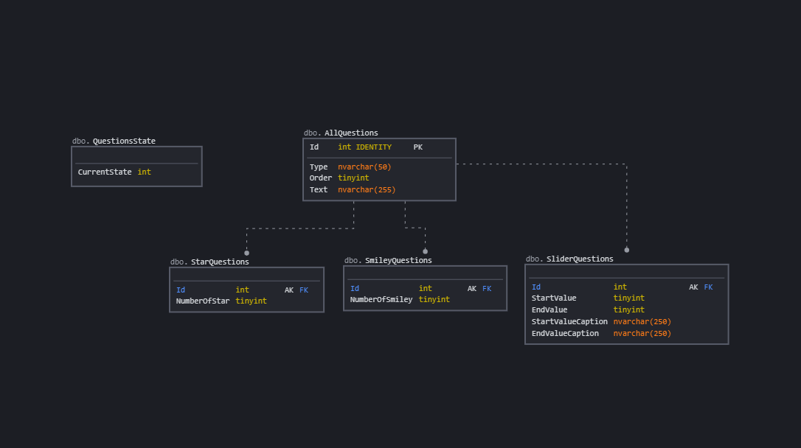

The database consists of Five tables:

* QuestionsState: This table only consists of an Int and is used to determine the current state of the data in the other tables, so It’s basically a table that the developer can access and see if the current application data is up to data with the data in the database or not.
* AllQuestions: This is the main table for the data, it has an Id primary key, Type, Order, Text, so basically the main Question attributes.
* SmileyQuestions: This is a sub type of Questions, it only has an Id and the extra data this sub type has, the Id is a FK for the allQuestions table, since the main data of any SmileyQuestions existing currently in this table are in the AllQuestions table.
* SliderQuestions: This is also another sub type of Questions, and the same behavior that the SmileyQuestions has also applies here.
* StarQuestions: This is also another sub type of Questions, and the same behavior that the SmileyQuestions has also applies here.

The database also consists of different Procedures that do different kind of operations,

Examples:

CREATE OR ALTER PROCEDURE [dbo].Update_CurrentState

AS

BEGIN

BEGIN TRY

BEGIN TRAN

UPDATE QuestionsState SET [CurrentState] = [CurrentState] + 1;

DECLARE @QuestionsStateCount INT;

SET @QuestionsStateCount = (SELECT MAX([CurrentState]) FROM QuestionsState);

IF (@QuestionsStateCount = 2147483647)

UPDATE QuestionsState SET [CurrentState] = 0;

COMMIT TRAN

END TRY

BEGIN CATCH

ROLLBACK TRAN

THROW;

END CATCH

END

GO

This procedure updates the current state of the database whenever we call any other procedures, and also handles overflowing of the int that currently lives in the QuestionsState table.

CREATE OR ALTER PROCEDURE [dbo].Add_StarQuestions

(@Text nvarchar(250), @Order INT, @NumberOfStar INT, @Id INT = NULL OUTPUT)

AS

BEGIN

BEGIN TRY

BEGIN TRAN

SET XACT_ABORT ON;

INSERT INTO AllQuestions VALUES('Star', @Order, @Text);

SET @Id = SCOPE_IDENTITY();

INSERT INTO StarQuestions VALUES(@Id, @NumberOfStar);

EXEC [dbo].Update_CurrentState;

COMMIT TRAN

END TRY

BEGIN CATCH

ROLLBACK TRAN

THROW;

END CATCH

END

GO

This procedure takes care of creating a new question of type star, which basically inserts into the AllQuestions table, then inserts into the StarQuestions table.

CREATE OR ALTER PROCEDURE [dbo].Update_StarQuestions

( @Text nvarchar(255), @Order INT, @NumberOfStar INT, @Id INT )

AS

BEGIN

BEGIN TRY

BEGIN TRAN

SET XACT_ABORT ON;

DECLARE @totalRows INT;

SET @totalRows = 0;

UPDATE AllQuestions SET Text = @Text, [Order] = @Order WHERE Id = @Id AND Type = 'Star';

SET @totalRows = @totalRows + @@ROWCOUNT

UPDATE StarQuestions SET NumberOfStar = @NumberOfStar WHERE Id = @Id;

SET @totalRows = @totalRows + @@ROWCOUNT

if (@totalRows = 2)

EXEC [dbo].Update_CurrentState;

COMMIT TRAN

END TRY

BEGIN CATCH

ROLLBACK TRAN;

THROW;

END CATCH

END

GO

This procedure takes care of updating StarQuestions, which all it does is Update the AllQuestions table with new data, then updates the StarQuestions table with the new data, then just checks if 2 rows were affected, if so update the CurrentState column in the QuestionsState indicating that a Question was updated.

Other procedures exist as well for each Questions type etc and for each operation, with all of them being a transaction to make sure that everything correctly happens and with try catches to catch out any errors that might arise, and they can be all found in the SQL file that exists with this project.